Timing magnetos to the Renault 4P
The maintenance manual describes timing the magnetos to the engine in the retarded position.This isn't an excellent idea because the magneto spends its working time fully advanced,and is only retarded for starting. So if the magneto is timed to the engine in the retarded position, the magneto pawls advance the timing with an increase in engine rpm to an approximation of the correct firing point, depending on how much the pawls are worn.
Far better to time the magnetos to the engine in the advanced position, and have the retarded timing an approximation depending on the wear of the pawls. To do this, a new timing mark needs to be made on the prop hub disk, and the first thing is to check whether someone has already marked the disk at 35 degrees BTDC sometime since manufacture.
A formula from the Zeus book was applied as follows:
Knowing that the disk radius is 85mm and that one angle is 35 degrees, (therefore the other two angles of an isosceles triangle are 72.5 degrees), the formula is :
a = 85 x sin 35 = 51.11mm where "a" is the side opposite to the apex
Sin 72.5
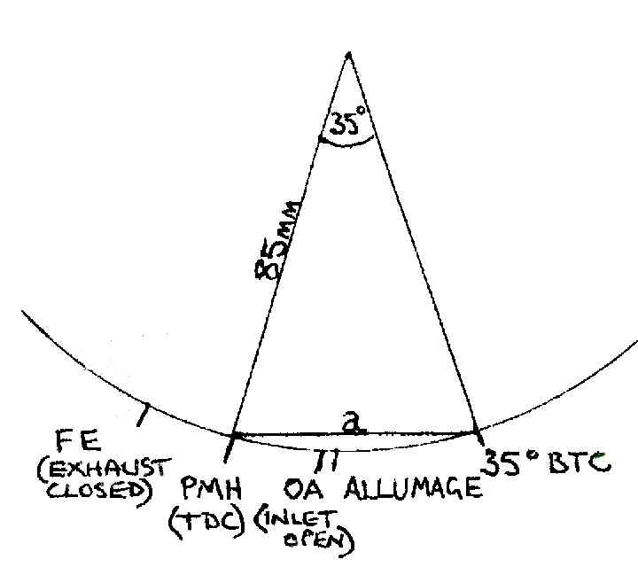
Take a ruler or a pair of dividers and measure in a straight line(not around the circumference) from the edge of the disk at the TDC mark to where 51mm hits the edge of the disk, make a mark, and here is your 35 degrees BTDC.
IMPORTANT! REMOVE ONE SET OF PLUGS AND ALL H.T. LEADS!
Next set the pointer to the new mark on the disk at 35 degrees BTDC, on the compression stroke of No.1 cylinder.
Beginning with the right hand magneto, the one with the impulse, set the rotor contact to point at the No. 1 H.T. lead, feeling for the "e" gap where the magnets hold the rotor in position.
Remembering that we need to fit the magneto to the engine in the advanced position, remove the points cover and turn the pinned castle nut fully anti-clockwise, which fully advances the magneto advance pawls.
Check that the pawl is not too stiff, which can mean that it is jammed with dirt or corrosion, in which case it will need to be stripped on a bench and cleaned out, and the pawl lubricated.
The magneto can now be mated in place, and held with just one bolt for the time being.
Next, connect a timing light. Turn the prop back 20 degrees or so and keeping the magneto fully advanced, tap the prop in the direction of rotation with the heal of the hand until the points just open. If the pointer isn't now at the timing mark, remove the magneto and slacken the nut of the magneto drive through bolt which links the drives through the engine. The notched coupling can now be adjusted in 3 degree increments so that the points of the magneto when refitted, just open.
It may take a bit of fiddling around to get this just right, it is better to be slightly on the retarded side, than advanced.
The same procedure is applied with the left hand magneto except that the direction of rotation is now clockwise, and the advance pawl must be kept fully clockwise when timing the magneto to the engine.
The arrangement of the magneto drive coupling is such that the L/H magneto should be adjusted only after the R/H magneto adjustments are complete.
Note: If you are going to continue with the original timing mark on the disk, remember to retard the magneto pawls instead of advancing them, before fitting the magnetos to the engine.

